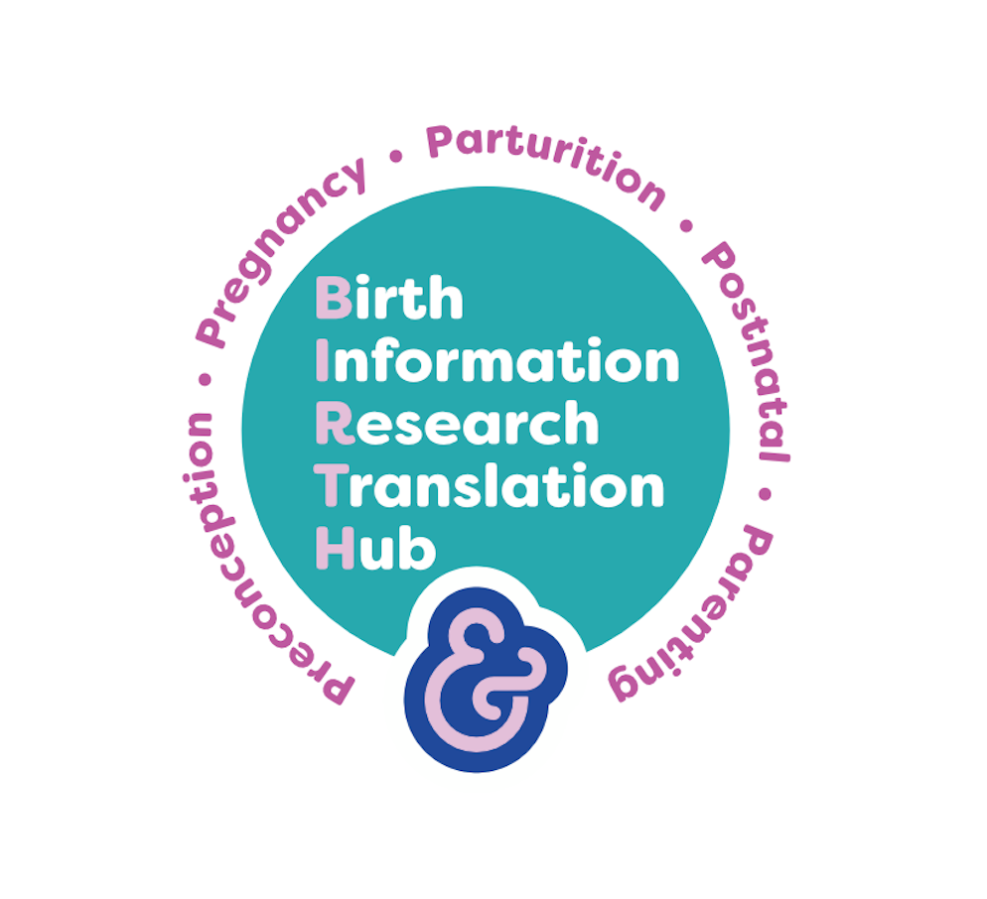

BIRTH, INFORMATION, RESEARCH & TRANSORMATION HUB

Process for reviewing resources

The resources within BIRTH have been co-created by a global community, who have suggested or shared resources via email and social media. The quality of the resources will therefore be influenced by personal preference or bias.

This basic review/screening process will allow for some quality control.

- Editorial Board invited to participate, to support process
- Resources will be received via email birthrepository@gmail.com and reviewed by the Editorial Team using the set criteria. See table below.
- Should there be a reported concern about any resource, three members of the Editorial Board will be invited to comment on the following aspects of the submitted resource

Table 1 Criteria for resources

Type of resource (please delete) | Academic paper/opinion paper/commentary/ film/
Please tick
Academic papers | Yes | No | Comment
Is the subject appropriate?
Does it pertain to the five Birth topics?
Is it free of (personal) opinion or bias?
Is it evidence based and correctly referenced?
Opinion papers
Is it culturally sensitive and respectful of all peoples, genders, walks of life?
Is it well-founded (in evidence or other reliable/respectable source?
Websites
Is it culturally sensitive and respectful of all peoples, genders, walks of life?
Is it well-founded (in evidence or other reliable/respectable source?
Films/videos
Is it culturally sensitive and respectful of all peoples, genders, walks of life?
Is it well-founded (in evidence or other reliable/respectable source?

